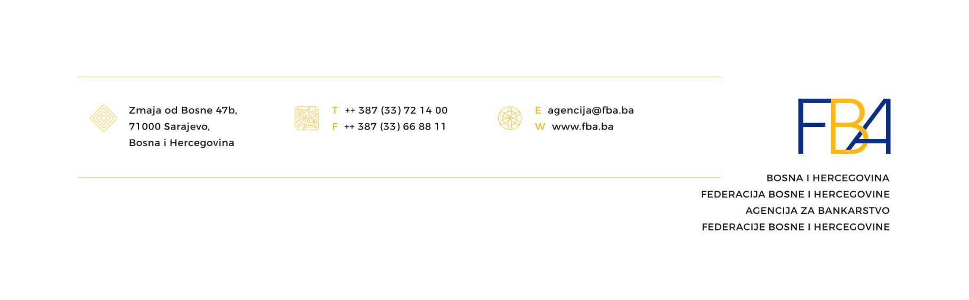

Number: 03-1-2755/20

Sarajevo, July 01st, 2020

**TO ALL BANKS**

**IN THE FEDERATION OF BIH**

**Attn: Chairwoman/Chairman of the Bank’s Management**

**Subject: Request for Action – Systemic Risk Management Relating to Adverse Economic Effects of „COVID-19“ Virus Disease Outbreak**

Under the Banking Law („Official Gazette of the Federation of BIH“, no. 27/17), systemic risk is a risk of disturbances in the financial system which may have serious adverse effects on the financial system and economy as a whole. The Federation of BIH Banking Agency (hereinafter: Agency) assesses the systemic risk exposure and effects with the banking system in the Federation of BIH, in order to maintain the banking system’s stability. The Agency believes that the adverse economic effects of the „COVID-19“ virus disease outbreak (hereinafter: pandemic) may increase the systemic risk exposure, and that active action by banks is required to manage the risks that may be realized during or after the pandemic. The systemic risk in the current circumstances does not refer only to systemic banks and key functions, but may be related to actions of one or more bank in the form of inadequate reaction to the expected adverse economic effects.

In order to appropriately treat the systemic and other pandemic-related risks, the following is required:

1. **Review and update of risk management strategies, policies, procedures and other internal regulations in accordance with the Decision on the Risk Management in Banks („Official Gazette of the Federation of BIH“, no. 81/17);**

The risk management approach must be adjusted to the current and expected needs during and after the pandemic along with avoiding activities which may lead to further adverse economic effects on the bank, banking system and economy. Avoiding of activities is particularly expected in credit risk management by exposures or portfolios, and as a result of abrupt or short-term approaches (so called: exit strategies, rapid withdrawals, terminations of existing arrangements and the like), without taking into account the effects on the banking system and economy. Under the Decision on the Temporary Measures to Be Applied by Banks to Mitigate the Adverse Economic Effects Caused by „COVID-19“ Virus Disease („Official Gazette of the Federation of BIH“, no. 22/20), when defining the modalities for legal entities which have exposures in other banks and non-depository financial institutions, the bank should take active action towards concerted action with other banks and non-depository financial institutions in finding a common modality for subsequent adjustment of real abilities of the repayment of credit obligations. According to the Banking Law, when passing measures for individual banks, the Agency shall also appreciate the degree to which the bank is endangering the financial discipline and seamless functioning of the banking system.

The measures passed by the Agency in the period of the pandemic for the purpose of maintaining the banking system’s stability refer to liquidity management, capital and creating of opportunities for an active role of banks in the period of the recovery of the economy after the pandemic. The recovery of the economy constitutes an important precondition for maintaining the banking system’s stability, and continuous financing of clients through sustainable credit arrangements needs to be ensured for that purpose. When updating regulations on risk management and exposure limits, banks are expected to review and optimize risk exposures outside Bosnia and Herzegovina, particularly in the form of exposures based on foreign issuers’ securities, all until such time when adequate and reliable assessments of risks and effects of the pandemic on other systems have been established.

Also, banks are expected to actively identify risks, especially credit, operational, liquidity and funding risks from the aspect of the pandemic’s impacts, assess and recognize in a timely fashion the effects in their financial statements and update on an ongoing basis their business plans, capital and liquidity plans on the basis of the most recent assumptions and assessments.

1. **Improving the efficiency of the processes for determining appropriate modalities in the manner that viable payment models are determined for the majority of the bank’s clients;**

Based on the Decision on the Temporary Measures to Be Applied by Banks to Mitigate the Adverse Economic Effects Caused by „COVID-19“ Virus Disease („Official Gazette of the Federation of BIH“, no. 22/20) and the Decision on the Amendments to the Decision on the Temporary Measures to Be Applied by Banks to Mitigate the Adverse Economic Effects Caused by „COVID-19“ Virus Disease („Official Gazette of the Federation of BIH“, number: 37/20), the time limits for the application and manner of the cessation of the validity of these decisions were defined. In the period of the validity of the decisions, the bank shall set up adequate processes, which includes informing the business network within the bank and clients fully and accurately about the provisions from the decisions.

The Agency expects that, in the period until September 30th, 2020, the appropriate modalities for the majority of the bank’s clients to which the decision applies can be determined, along with the continuation of the application of all provisions of the Decision on Credit Risk Management and Determination of Expected Credit Losses („Official Gazette of the Federation of BIH“, no. 44/19) concluding with December 31st, 2020.

1. **Informing the Agency about any change in the strategies, policies, procedures and other internal regulations with potential material effects on the bank’s risk profile, business plans which were developed before the pandemic, bank’s market share and systemic risk;**

Banks shall, before revising their internal regulations, i.e. scheduling the sessions of the competent bodies of the bank in which the amendments to the strategies, policies and other internal regulations that affect the bank’s risk profile to a significant extent are to be adopted, notify the Agency of the amendments, along with providing it with the proposals of those regulations.

1. **Prompt notification of the Agency in the circumstances requiring the triggering of the business continuity plan and the recovery plan, which needs to include all relevant facts and circumstances related to that.**

The Agency refers banks to consistent implementation of the recommendations of the competent ministries and institutions, particularly the segment concerning the employee and client health protection measures.

Appreciating the importance of maintaining the banking system’s stability in the Federation of BIH, banks are expected to, according to the circumstances and without delay, undertake measures on the review and implementation of the business continuity plans, and to, according to the current situation, ensure maintenance of the availability and security of the key services for the final customers. In the event of a material disturbance in the business operations which may result in unavailability of the key services for the clients, banks shall notify the Agency of this before the interruption in the service provision.

Under the regulatory requirements for recovery plans, banks shall monitor on a regular basis the list of defined indicators from the recovery, and to provide information on the evolution of those indicators to the bank’s management at least on a weekly basis and to the Agency on a monthly basis.

Sincerely,

**D I R E C T O R**

**Jasmin Mahmuzic**

(signed and stamped)